How to Reset SA password in SQL Server 2005

Article Source:
http://recoverlostpassword.com/article/reset-sa-password-in-sql-server-2005.html
SA user (abbreviation for “System Administrator”) is the administrative login for MS SQL Server. Have you ever thought about such situation: what will you do if you forgot SQL Server SA password? Reinstall MS SQL Server or just drop everything and walk out of here. For whatever reason you forgot SQL Server SA password and the windows account told you don’t have the permissions to change SA password, this article will demonstrate Resetting SQL SA password for several options.
Options 1: Change SQL SA password From a Command Prompt
To change SQL SA password, you have to execute following commands from command prompt of your SQL server:
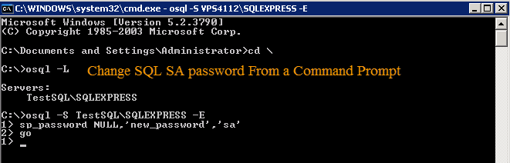
- Go to the command prompt of the server and type in command prompt osql –L
- Copy full name of SQL Server and type:
OSQL -S <insert_servername_here> -E
- Execute the following query:
sp_password NULL, ‘<insert_new_password_here>’, ’sa’
GO
Now try to login to MS SQL using the new password. If you are bored of the old black screen (Command Prompt), you may like the graphical interface option below.
Options 2: Reset SA Password Using SSMS

SSMS (MSSQL Server Management Studio) is the own database management tool of MSSQL. Here are steps to reset SA password by using SSAM:
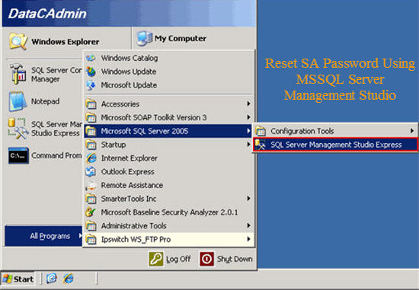

- Open SSMS management console. This is usually under Start -> All Programs -> Microsoft SQL Server 2005 -> SQL Server Management Studio Express.
- Connect to your instance of SQL Server via Windows Authentication.
- Once open, navigate to “Logins” object under the “Security”. Once expanded, right-click on the ‘SA’ user, and choose Properties.
- Now, enter desired password in front of “Password” and “Confirm Password” field and click OK.

That is all! You have now reset SA password for your instance of SQL Server 2005. Please note the password change for your records, as remote administration of your database relies heavily on this particular user.

Options 3: Reset SA password With SmartKey SQL Password Recovery

I think the easiest and most efficient way to reset SA password is to take use of SQL Password Recovery, which is designed to reset lost or forgotten user and administrator password for MS SQL server. I have used it to reset SQL SA password successful on SQL 2005. The whole process of resetting SAL SA password can be easily divided into three steps:
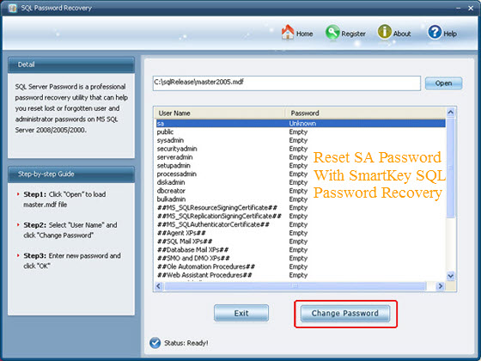
- Run the SQL Password Recovery program and then click “Open” to load the master .mdf file.
- Select SA user name to reset the forgotten SA password, or select any other user name which you forgot the password. Click “Change Password” to reset password.
- Enter the preferential password and click “OK”.

You can now user your newly reset SA password to login into the locked SQL Server.

